

BAHRIA UNIVERSITY (KARACHI CAMPUS)

Software Project Management (SEN-410)

ASSIGNMENT # 4 – Fall 2024

Problem Based Learning (PBL) Based on: CLO-2

Class: **BSE-7A/B** Submission Deadline: **31st Dec 24**

Course Instructor: **Engr. Majid Kaleem** Max Marks: **06**

**Name: Muhammad Shoaib Akhter Qadri Enrollment No: 02-131212-009**

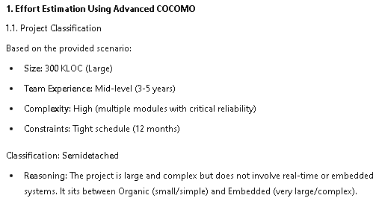

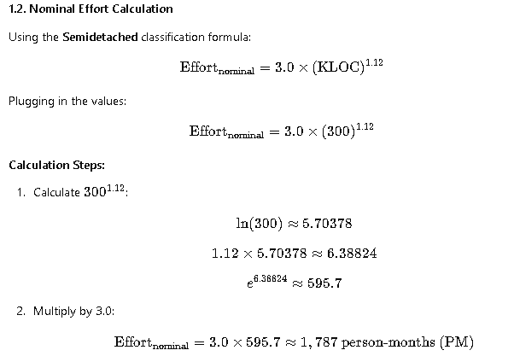

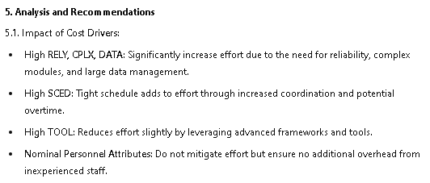

Good Luck!